NOTICE OF RACE
Open Dutch Championship 2.4mR

Organized by ZV Zuidlaardermeer
Under the auspices of the Royal Nederland’s Watersport Association (RNWA) From 13th to 15th September
Location: Zuidlaardermeer, Kropswolde

[NP] denotes that a breach of this rule will not be grounds for a protest by a boat. This changes RRS 60.1(a

1. RULES
1.1. The event will be governed by the rules as defined in The Racing Rules of Sailing (RRS). The Prescriptions of the RNWA can be found at www.sailing.org/documents/racingrules/national_prescriptions.php
1.2. The ‘Rules for Championships Sailing, Windsurfing and Kiteboarding’ will apply.
1.3. If there is a conflict between languages the text in the English language will take precedence
1.4. Every person on board who has his domicile in the Netherlands shall have the appropriate license.
1.5. RRS Appendix T, Arbitration applies.
1.6. RRS Appendix P applies (details in S.I.)
1.7. [DP] Competitors and support persons shall comply with any reasonable request from an event official. Failure to comply may be misconduct. - Reasonable actions by event officials to implement COVID-19 guidance, protocols or legislation, even if they later prove to have been unnecessary, are not improper actions or omissions.
1.8. RRS 90.3(e) applies with a time limit of 48 hours. This changes RRS 90.3e

2. SAILING INSTRUCTIONS
The sailing instructions will be available at least 3 days before the start of the event, on the website www.zvzuidlaardermeer.nl

3. RADIO COMMUNICATIONS
Except in an emergency a boat that is racing shall not make voice or data transmissions and shall not receive voice or data communication that is not available to all boats.

4. ELIGIBILITY AND ENTRY
4.1. The event is open to all boats of the 2.4 mR class.
4.2. Eligible boats may enter at the following website: Zeilvereniging Zuidlaardermeer (zvzuidlaardermeer.nl)) in Kropswolde.
The required fee shall be transferred to the following bank account:

Iban nummer: NL 57 ABNA 0608 3993 45

5. FEES
5.1. Required fees are as follows: € 120,-
5.2. Other fees:
Late entry fee: € 130,- (after5th of September)

6. CREW LIMITATIONS
Class rule 7 (a) is restricted as follows: “Only one person shall be on board whilst racing. The person shall be named on the entry form”

7. ADVERTISING
Boats may be required to display advertising chosen and supplied by the organizing. If this rule is broken, World Sailing Regulation 20.9.2 applies.

8. SPARE

9. SCHEDULE
9.1. Registration: Thursday 8th September 12:00 to 20:00 hours. Friday 9th September 8:00 to 10:00 hours.

9.2. Dates of racing

DATE NUMBER WARNING SIGNAL 2ND RACE 3RD RACE 4TH RACE
OF 1ST RACE
RACES
SEPTEMBER | 13 | 3 | 11:55 | ASAP | ASAP | X
SEPTEMBER | 14 | 4 | 09:55 | ASAP | ASAP | ASAP
SEPTEMBER | 15 | 3 | 09:55 | ASAP | ASAP | X

9.3. The scheduled time of the warning signal for the first race on 8th September is 11:55 hrs.
9.4. On the last day of the regatta no warning signal will be made after 14:00 hrs.

- MEASUREMENTS
Each boat shall produce a valid measurement certificate.

- SPARE

12. VENUE
12.1. The race office is located at the following address:
ZV Zuidlaardermeer
Meerweg 58
9606 PP Kropswolde.
12.2. The location of the regatta harbor is at the same site.
12.3. The racing area will be the Zuidlaardermeer.

- THE COURSES
13.1. The Attachment B shows the courses to be sailed.

- SPARE

15. SCORING
15.1. Four races are required to be completed to constitute a series.
15.2. (a) When fewer than 5 races have been completed, a boat’s series score will be the total of her race scores.
- When 5, 6, 7 or 8 races have been completed, a boat’s series score will be the total of her race scores excluding her worst score.
- When 9 or more races have been completed, a boat’s series will be the total of her race scores excluding her worst 2 scores.

16. SPARE

17. RIGHTS TO USE NAME AND LIKENESS
By participating in this event competitors automatically grant to the organizing authority and the event sponsors the right, in perpetuity, to make , use and show, at their discretion, any photography, audio video recording, and other reproductions of them made at the venue or on the water from the time of their arrival at the venue until their final departure, without compensation.

18. RISK STATEMENT
18.1. RRS3 states: ’The responsibility for a boat’s decision to participate in a race or to continue to race is hers alone.’ By participating in this event each competitor agrees and acknowledges that sailing is a potentially dangerous activity with inherent risks. These risks include strong winds and rough seas, sudden changes in weather, failure of equipment, boat handling errors, poor seamanship by other boats, loss of balance on an unstable platform and fatigue resulting in increased risk of injury.
Inherent in the sport of sailing is the risk of permanent, catastrophic injury or death by drowning, hypothermia or other causes.
18.2 The organizing authority and their officers, members and volunteers do not accept liability for loss of life or property, or personal injury or damage caused by or arising out of the regatta. Competitors take part in the regatta at their own risk.
18.3 The establishment of the notice of race and the sailing instructions in no way limits or reduces the complete and unlimited responsibilities of a competitor being solely and entirely responsible for the management of a boat he is sailing.
18.4 All competitors shall maintain their boats in a safe condition.
18.5 A competitor shall be of good health and a competent sailor capable of racing.
18.6 At-fault occurrences to other boats are the responsibility of the helmsman. Competitors are not covered by any liability insurance provided by the organizing authority and should provide their own coverage for personal goods and liability protection. The organizing authority recommends that competitors consult their own insurance carriers to assure they are covered at this event and regarding additional personal liability insurance coverage.

19 INSURANCE
Each participating boat shall be insured with valid third-party liability insurance with a minimum cover of Euro 1.500.000 per event or the equivalent.

20. PRIZES
The Helmsman of the winning boat of the championship acquire the title "Class Champion" and acquires the Pennant of the RNYU.
Other prizes will be given as follows:
The helmsmen of the 1st, 2nd and 3rd boat in the total score of the championship receive a prize given by the Dutch 2.4mR Class Association.

21. FURTHER INFORMATION
For further information please contact:
Rik Klok
E-mail: info@zvzuidlaardermeer.nl
Website: www.zvzuidlaardermeer.nl
Race officer: Rik Klok
Chairman protest committee: Peter Nannenberg
Chairman technical committee: Jan ten Hoeve

GENERAL INFORMATION

- Social events: Are to be made up for the coming month:

13th September Happy Hour
Buffet

14th September Break first at the club
Happy Hour
BBQ (weather depended)

15th September Break first at the club
Price giving Ceremony

Accommodation:

  - Campers and Tents are free to set up at the club site, full is full
  - Hotels Are in Hoogezand or in Zuidlaren Try www.booking,com

Addendum A : The Racing Area

The Racing area covers all of the Zuidlaardermeer, but we try to stay to the given Area IN THE map.

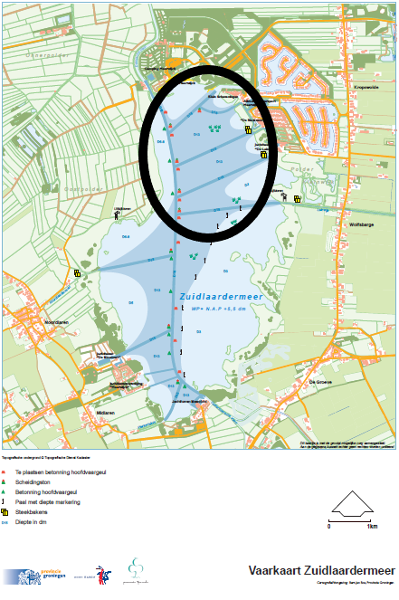

Addendum B: The Courses
